CoalFire Terraform Project

Resources Used
- Docs overview | hashicorp/azurerm | Terraform | Terraform Registry
- Visual Studio & VS Code Downloads for Windows, Mac, Linux
- PowerShell
- Github
- Azure Portal
- Cloud Services Azure Technical Challenge

Why HashiCorp for this project?
- I used HashiCorp Configuration Language (HCL) for this project. Instead of choosing to go with CoalFires Open Source they provided, since it has been some time working within Terraform, I decided to use all of the code provided directly off of the HashiCorp website.
- Why I chose to use HCL for this project:
- Terraform uses HCL, a declarative language designed for infrastructure as code
- Benefits of HCL: Human-Readable syntax- Easy to understand and maintain, Declarative approach- Focus on desired state rather than procedural steps, Extensible- Supports modules, variables, and reusable components, and works seamlessly across multiple cloud platforms.
- Why is this a good resource?
- Industry standard for IaC
- Strong community support and documentation
- Enables automation, consistency, and scalability in cloud deployments.

Project Files Explained
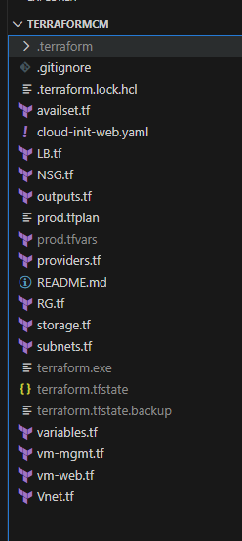
Core & Environment Files
- providers.tf
Declares the AzureRM provider (and any others), config settings (e.g., features block), and optionally provider version constraints.
Why: Central place to control provider versions and authentication method (e.g., Azure CLI, Workload Identity, service principal).
- variables.tf
Defines input variables (name, type, description, defaults) used by your configuration.
Why: Makes your code configurable and reusable across environments (e.g., location, resource names, CIDRs).
- outputs.tf
Exposes useful values after terraform apply—like public IPs, resource IDs, or URLs.
Why: Quick discovery and integration points for automation or documentation.
- prod.tfvars
Your environment-specific values for variables (e.g., resource group name, location, CIDRs, admin usernames, cloud-init path).
Why: Keeps environment overrides separate from generic defaults—so you can run -var-file="prod.tfvars" to target “prod” cleanly.
- prod.tfplan (optional binary/JSON plan you saved)
A serialized plan output from terraform plan -out=prod.tfplan you can later apply with terraform apply prod.tfplan.
Note: You typically don’t commit plan files to Git—they’re ephemeral and environment-specific.
- .terraform.lock.hcl
The dependency lock file pinning exact provider versions used in your last init.
Why: Ensures consistent provider versions across machines/CI runners (you do commit this).
- .terraform/ (folder) & terraform.exe
Local working directory that holds downloaded providers & state hooks; terraform.exe is the CLI binary.
Best practice: Don’t commit .terraform/ or the Terraform binary—add them to .gitignore.
- terraform.tfstate, terraform.tfstate.backup
Local state tracking real-world resources.
Best practice: Do not commit state. Prefer remote state (e.g., Azure Storage) with state locking to avoid drift and conflicts.
- .gitignore
Ensures sensitive or generated files are excluded from Git (e.g., .terraform/, state, local tfvars with secrets, SSH keys, plan files).

Network & Infra Building Blocks
- RG.tf
Creates the Resource Group that holds all your Azure resources.
Why: Single place to name and tag your deployment boundary.
- Vnet.tf
Defines the Virtual Network (VNet)—address space, DNS settings if any.
Why: Network backbone for subnets and security boundaries.
- subnets.tf
Declares subnet(s) like subnet_mgmt and subnet_web, with CIDR ranges and optional delegation/service endpoints.
Why: Logical segmentation (mgmt vs web) and policy application via NSGs/UDRs.
- NSG.tf
Creates Network Security Groups and rules:
  - Mgmt NSG: allow SSH from trusted CIDR; deny all else.
  - Web NSG: allow HTTP from AzureLoadBalancer and SSH only from mgmt; deny all else.
Why: Enforces least privilege at subnet level.
- LB.tf
Defines Load Balancer, frontend IP, backend pool, health probes (HTTP/80), and LB rules.
Why: Distribute traffic to web VMs; health probe is why the NSG allows AzureLoadBalancer on 80.
- availset.tf
Creates an Availability Set for VMs (fault/update domains).
Why: Improves resilience against host failures when not using VMSS.
- storage.tf
Any Storage Account or disks you provision (possibly for boot diagnostics, logs, or data).
Why: Centralized storage resource with proper SKU and access controls.
Compute
- vm-mgmt.tf
Provisions the management VM (Ubuntu 22.04 per your SSH transcript).
  - Injects SSH public key, sets admin_username.
  - Attaches NIC to mgmt subnet/NSG.
Why: Secure admin box for operations and testing (and SSH jump host if needed).
- vm-web.tf
Provisions web VM(s) and sets:
  - custom_data = filebase64(local.cloud_init_web_path)
  - NIC to web subnet/NSG & LB backend pool.
Why: Bootstraps Apache and a test page via cloud-init and integrates with LB.
- cloud-init-web.yaml
Cloud-init for web VMs to install Apache, enable service, and write a simple HTML page.
Why: Idempotent first-boot configuration without manual SSH provisioning.

.tfvars Terraform file, explained

Why I used the prod.tfvars file.
- Separation of concerns: Keeps environment-specific values out of generic defaults.
- Reusability: You can run dev.tfvars, test.tfvars, prod.tfvars with the same codebase. (For this project because of time, I chose to only include the prod.tfvars file) Other projects I would create the dev.tfvars file for testing purposes.
- Repeatable workflows: terraform plan -var-file="prod.tfvars" and terraform apply -var-file="prod.tfvars" become standard ops.
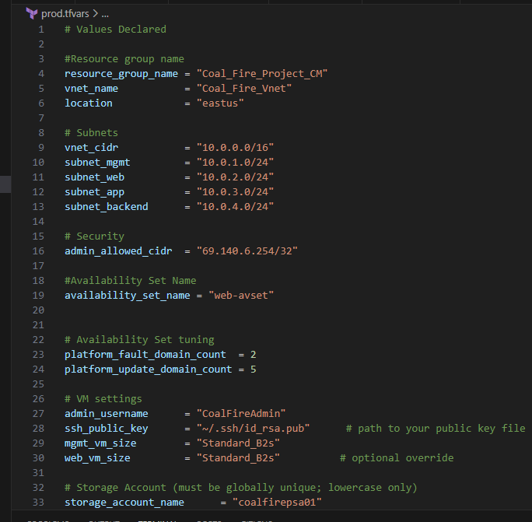

Best Practices for .tfvars
- Environment-specific files
- I could use these specific files and break it up: dev.tfvars, test.tfvars, prod.tfvars. Never hardcode environment values in variables.tf.
- Secrets handling
  - Prefer environment variables (TF_VAR_...) or a secrets manager (Azure Key Vault) over storing secrets in .tfvars.
  - If you must store non-critical secrets locally, name the file something like local.secrets.tfvars and gitignore it.
- Consistent naming & tagging
Capture naming conventions (prefixes/suffixes) and tags in .tfvars for consistent resource naming and governance.
- Do not commit sensitive .tfvars
Add patterns to .gitignore
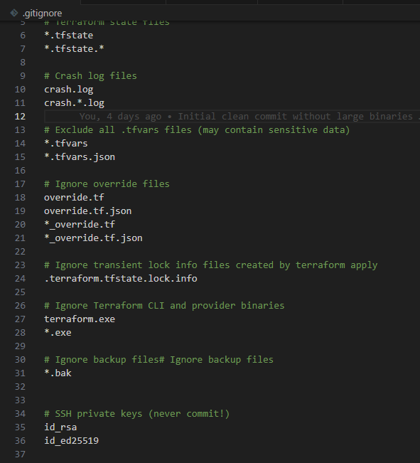

SSH Keys Explained
- Generated a 4096-bit RSA key locally (id_rsa + id_rsa.pub) via PowerShell.
- Configured Windows ssh-agent and added the private key with ssh-add, so the key isn’t read from disk by Git processes.
- Only the public key was referenced by Terraform (e.g., ssh_public_key = "~/.ssh/id_rsa.pub" in your .tfvars or locals).
- Did not commit id_rsa or any private key file to GitHub—protected by .gitignore patterns and good hygiene (See screenshot above for my .gitignore file.

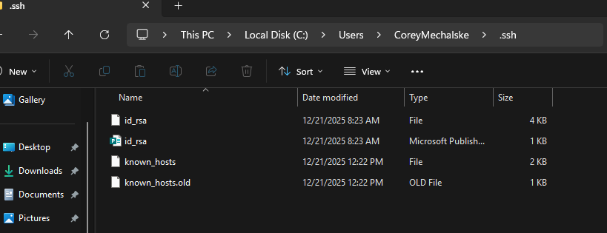

Using SSH to log into the VMs.
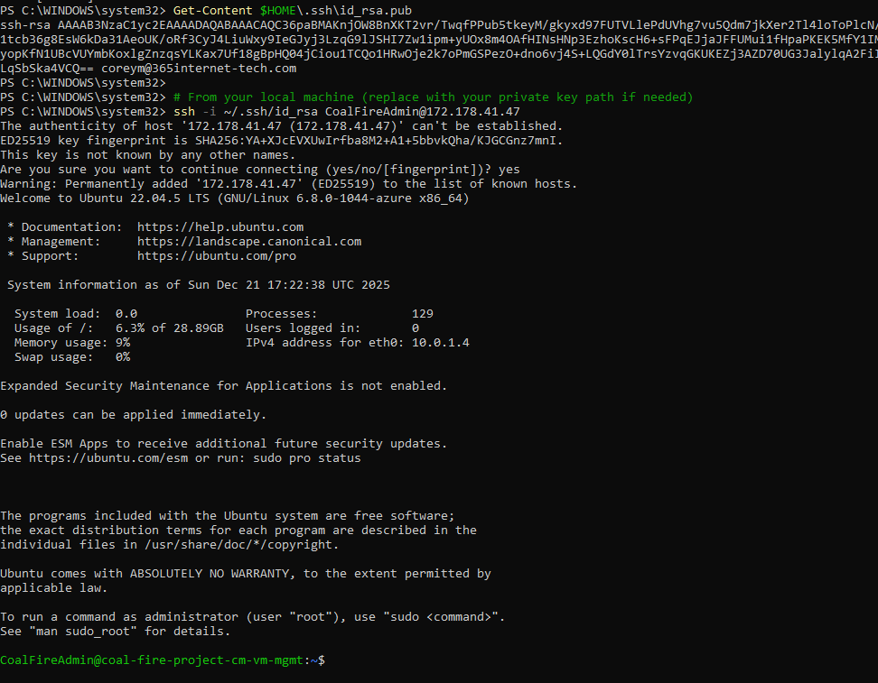
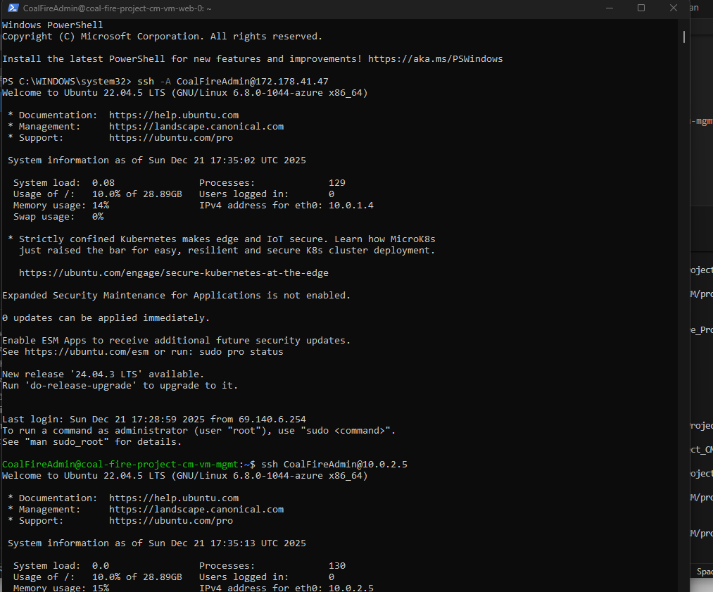
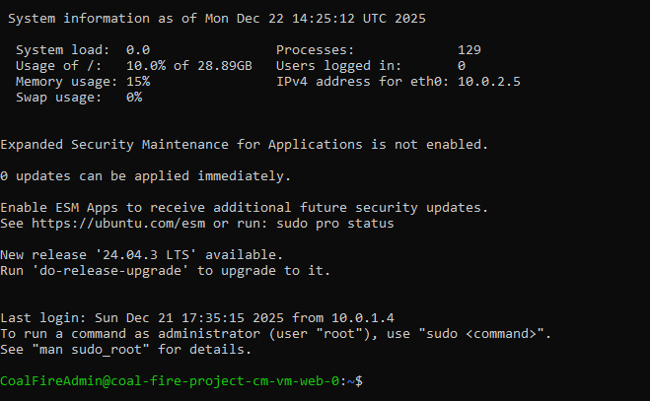

Azure Portal Environment/Resources
Resource Group Name- Coal_Fire_Project_CM
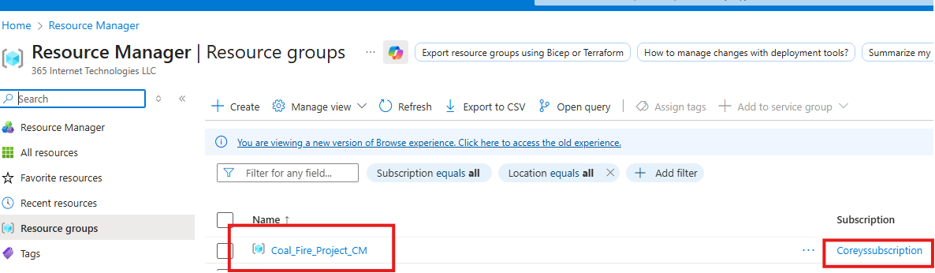

Azure Resources
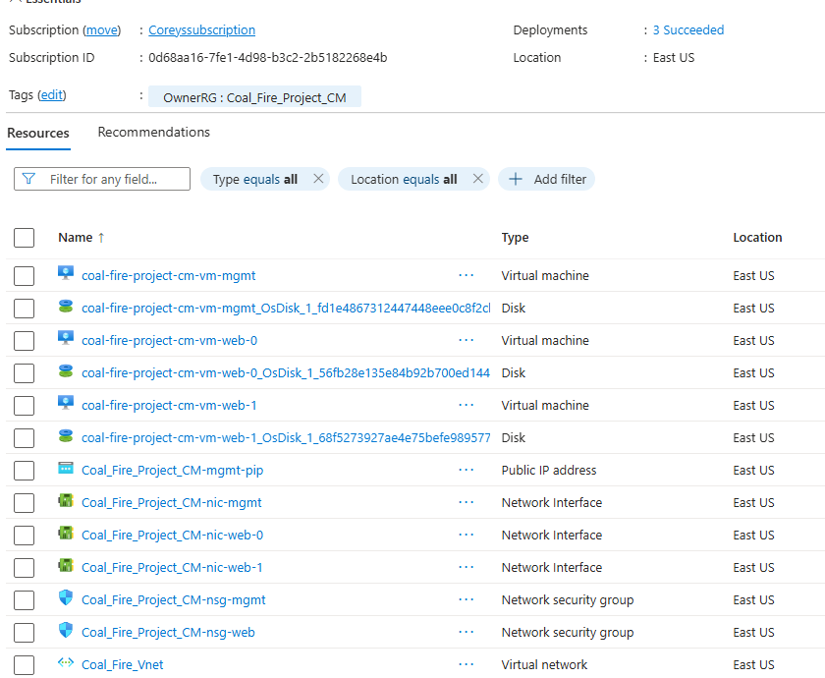
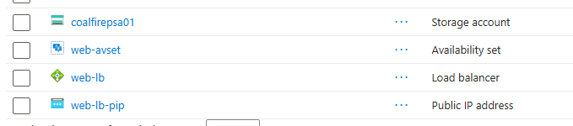

Virtual Machines
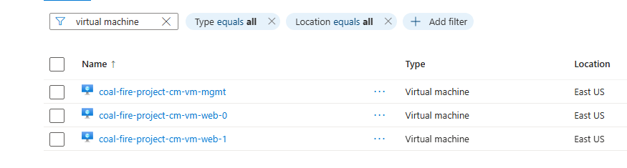
Disks
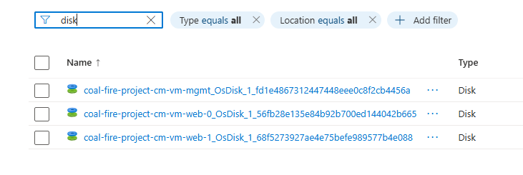
Availability Set
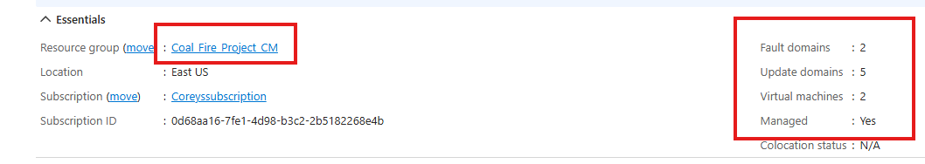
VNET/Subnets
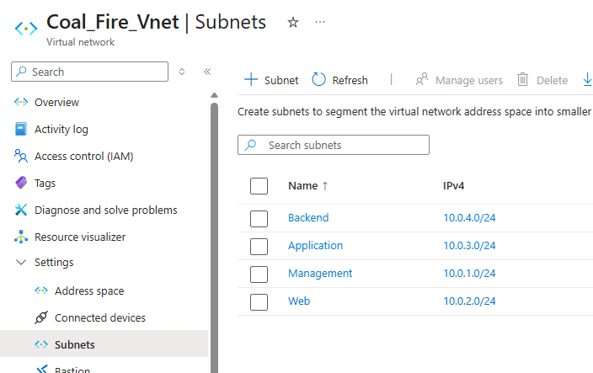

Load Balancer
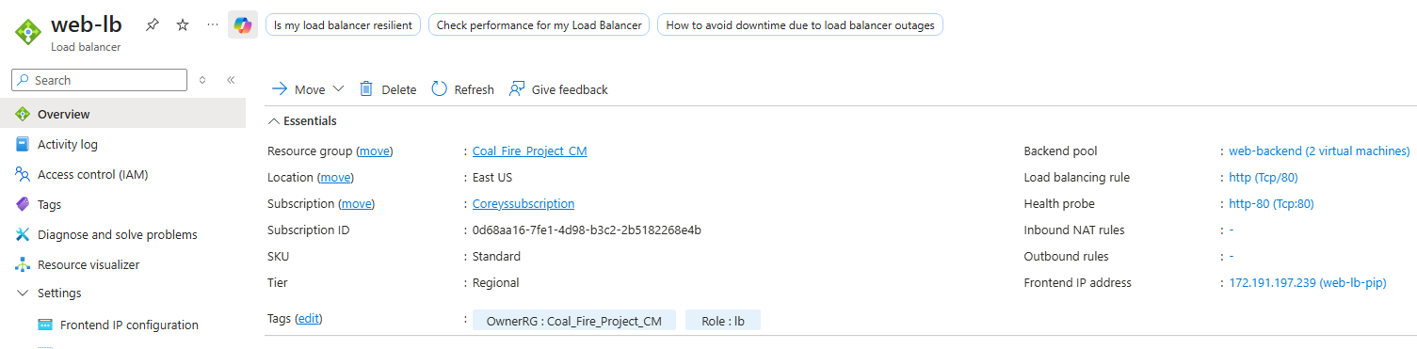
NSG’s

Storage Account/Containers
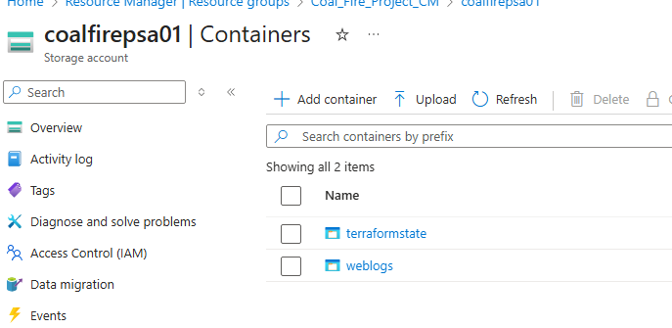

Network Interfaces
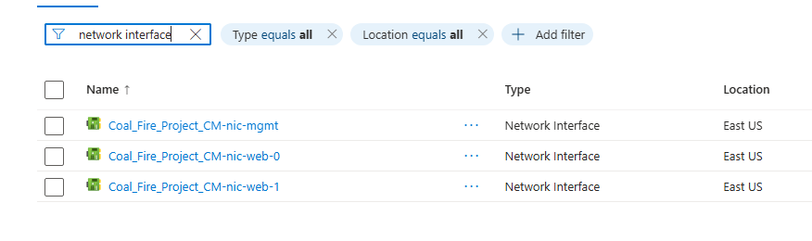
Public Ips
